

American International University-Bangladesh (AIUB)  
Department of Computer Science  
Faculty of Science &Technology (FST)  
Summer 20_21

Section: E  
Group No: 4

AIUB MEETING

A Software Quality Assurance Test Plan submitted

By

|  |  |  |
| --- | --- | --- |
| SN | Student Name | Student ID |
| 13 | Jui Saha Pritha | 17-35507-3 |
| 22 | Rajan Das Gupta | 18-36304-1 |
| 26 | Afrida Rahman | 19-39557-1 |
| 30 | S. M. Hasib | 18-36939-1 |
| 38 | Ehsanul Mostofa | 18-38383-2 |

Software Test Plan

for

<AIUB MEETING>

Version 1.0 approved

Prepared by

S. M. Hasib

Ehsanul Mostofa

Jui Saha Pritha

Rajan Das Gupta

Afrida Rahman

<American International University Bangladesh>

<24 June,2021>

Table of Contents

Revision History 3

1. TEST PLAN IDENTIFIER: RS-MTP01.3 4

2. REFERENCES 4

3. INTRODUCTION 4

Background to the Problem 4

Solution to the Problem 4

4. REQUEIREMNT SPECIFICATION 4

4.1 System Features 4

4.2 System Quality Attributes 5

4.3 System Interface 5

4.4 Project Requirements 5

5. FEATURES NOT TO BE TESTED 5

6. TESTING APPROACH 5

6.1 Testing Levels 5

6.2 Test Tools 6

6.3 Meetings 6

7. TEST CASES/TEST ITEMS 7

8. ITEM PASS/FAIL CRITERIA 7

9. TEST DELIVERABLES 8

10. STAFFING AND TRAINING NEEDS 8

11. RESPONSIBILITIES 8

12. TESTING SCHEDULE 9

13. PLANNING RISKS AND CONTINGENCIES 9

14. APROVALS 9

# Revision History

|  |  |  |  |
| --- | --- | --- | --- |
| Revision | Date | Updated by | Update Comments |
| 0.1 | 01-08-2021 | Hasib, S. M. | First Draft |
| 0.2 | 02-08-2021 | Mostofa Ehsanul | Second Draft |
| 0.3 | 05-08-2021 | Rajan Das Gupta | Third Draft |
| 0.4 | 06-08-2021 | Pritha, Jui Saha | Fourth Draft |
| 0.5 | 08-08-2021 | Mostofa Ehsanul | Fifth Draft |
| 0.6 | 09-08-2021 | Hasib, S. M. | Sixth Draft |
| 0.7 | 09-08-2021 | Bristy, Afsana Akter | Seventh Draft |
| 0.8 | 10-08-2021 | Bristy, Afsana Akter | Eight Draft |
| 0.9 | 12-08-2021 | Rajan Das Gupta | Ninth Draft |
| 1.0 | 12-08-2021 | Pritha, Jui Saha | Tenth Draft |

# TEST PLAN IDENTIFIER: RS-MTP01.3

# REFERENCES

<https://documentation.its.umich.edu/node/1771>

<https://teamsdemo.office.com/#/0/3>

[https://www.researchgate.net/publication/287902006_Virtual_conferencing_and_meeting_systems_Re](https://www.researchgate.net/publication/287902006_Virtual_conferencing_and_meeting_systems_Resources_for_online_connections)

[sources_for_online_connections](https://www.researchgate.net/publication/287902006_Virtual_conferencing_and_meeting_systems_Resources_for_online_connections)

<https://ieeexplore.ieee.org/document/7456682>

<https://www.techfunnel.com/information-technology/11-best-virtual-meeting-platforms-for-business/>

# INTRODUCTION

## Background to the Problem:

* During pandemic situation classes, meetings and seminars are switched into online platform like Microsoft teams, zoom, google meets, Slack etc. AIUB choosed Microsoft teams. A third-party software to conduct meetings.
* AIUB Doesn’t have any autonomous platform of their own to control or change it according to requirements. The third-party platform doesn’t have connectivity with AIUB server, So all the resources are storing in the third party server. So this not autonomous, efficient reliable and trustworthy.

## 

## Solution to the Problem

* The solutions to this problem are solving by make a video conference tool which name is AIUB Classroom. This tool can arrange an online class on this platform. So that faculty and students can gather virtually in one place. There have so many features to take attendance and online exam. This software can evaluate the exam paper like MCQ and another written exam by using its inbuilt AI image processing technology.
* This solution is particularly appropriate to solve the problem because In this pandemic there has no option to take classes and assessments without an online platform like AIUB Classroom. Other platforms like Google meets and Microsoft Teams are so much costly and it has some defendants. For this reason, If AIUB has such software they can use it easily and hassle-free. The solution is feasible to the meet the business objective because this software needs one-time investment but it can use unlimited hours and also it has an unlimited user feature. This will save money for this organization.
* AIUB Classroom is a software, this can provide video calling with a lot of users, all can gather here share their opinion and also can share knowledge in one platform. This software has so many features like attendance sheet, file sharing, image sharing, content management, and also give comment. There has some AI feature to take an online exam and evaluate exam paper easily. Hassle-free online classroom with unlimited room creation. The user interface of this software so user-friendly. Every students can easily operate this software.
* AIUB Classroom is a system designed to help users create online meetings quickly and intuitively. Available as an app or desktop download, offers a very basic free system serving up to ten participants,. It boasts low costs with the added beneﬁt of unlimited audio. Instead of a link sent through the program or email, The system allows ﬁle transfers and ﬂexible screen-sharing.
* AIUB is one of the biggest universities in Bangladesh. For this reason, they need their own personal online platform to handle all classes and seminars. AIUB Classroom will be the best solution in this pandemic to solve all the issues at this time.
* For solving this problem, there has so much software like Google meets, Microsoft Teams, ZOOM. This software basically follows the same requirement to make an environment of the classroom. But those software work perfectly for corporate meeting and business meeting. But there has not mush feature to handle a classroom and exam easily.
* AIUB Classroom is a highly versatile application that’s useful for virtual meetings and online presentations. The user is able to organize a virtual meeting room in which participants can interact at any time. The attendees can enter using a speciﬁc web link or from the Blackboard website. AIUB Classroom Collaborate also features an interactive whiteboard, the ability to create separate rooms for chats, and multipoint video. The presenter can record the session and share with other users at a later time. Attendees can participate using either a microphone or a telephone connection.

# REQUEIREMNT SPECIFICATION

## System Features

* Login: The system will be synced to the AIUB servers to access the login credentials (i.e. ID, Password)
* Students, Faculties and other officer can login to the system by the same interface
* From the interface of host, moving into the particular section, Host (Faculties, Organizers) can see a button to launch the meeting
* From interface of attendee if the faculty launces a meeting there will appear a joining button in the corresponding class section
* Only registered students of that section can enter to the meeting
* Students can be found by their id card from the attendee list
* Students can raise their hand
* Both host and attendee will have the option to turn on/off mic, turn on/off the camera, and screen share
* The activation of screen share option of the attendee will be authorized by the host
* Host can turn off camera and mic of all attendee by one click
* Host can pre-set the meeting time to automatic launch of the meeting in that particular time
* The will be a real time chat option with allow students and teachers to discuss in written form or share valuable contents
* Host can remove attendee from the meeting
* Hosts can terminate the meeting
* Host can download take list of attendee

Funtional Requirements

1. System login
   1. Only AIUB valid user ID and password will be accepted

Priority level: High

1. Validity check in the meeting
   1. Valid student for a particular section will be allowed to join the meeting
2. Log of every meeting
   1. After meeting end there will be a log written in timeline of the credentials of the class (i.e meeting started time, meeting end time , when an attendee joined or leave)

## System Quality Attributes

* Usability: When the host clicks on the meeting start button all the valid students will get the joining button real time
* Performance: Voice data transmission will not have no day
* Functional Suitability: Noise cancellation will reduce noise but will keep the voice clear
* Robustness: When a user talks his profile will pop up the screen and remain until he/she finishes
* Efficiency: The log will register as soon the class ends
* Funtional suitability: Video background blur feature will be able to detect the human in order to blur the back
* Portability: this can be added to the aiub portal
* Mentality : anytime updateable

## System Interface

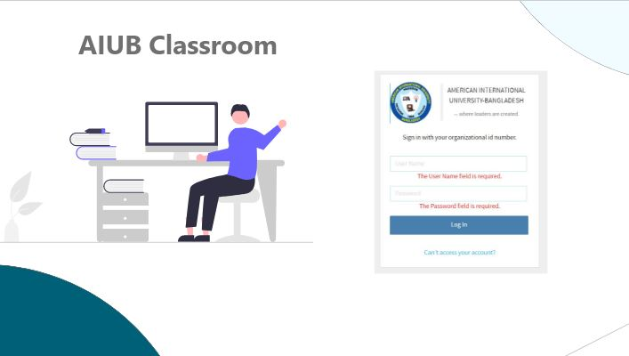

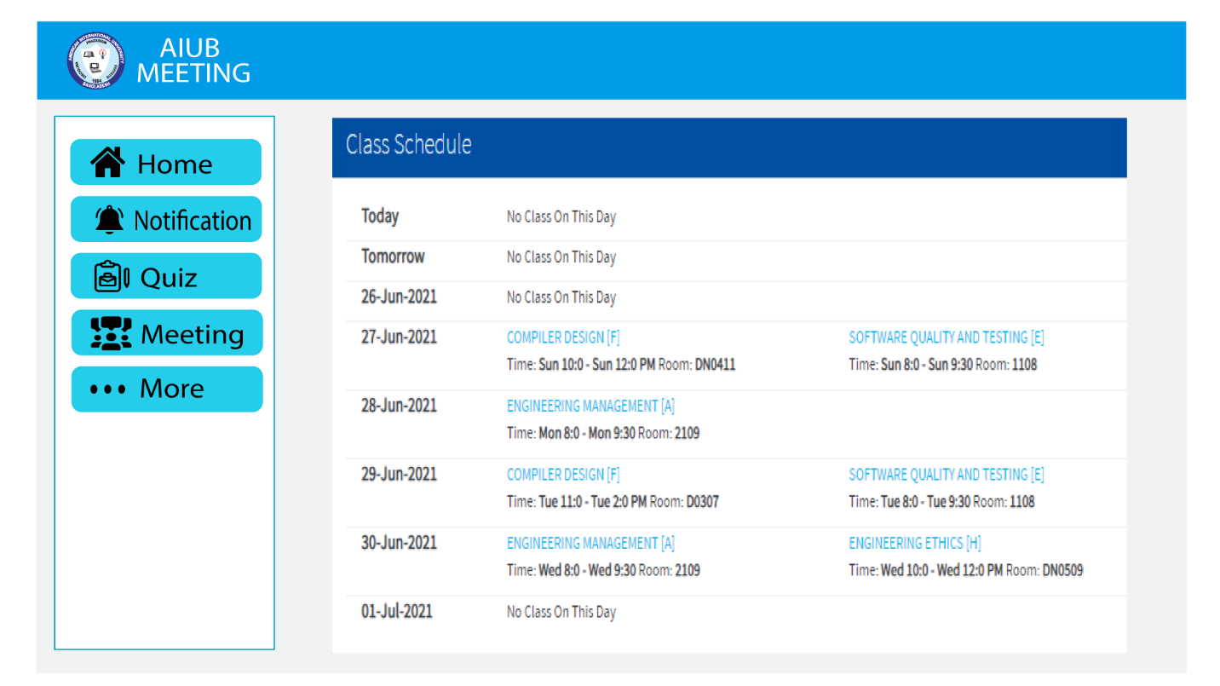

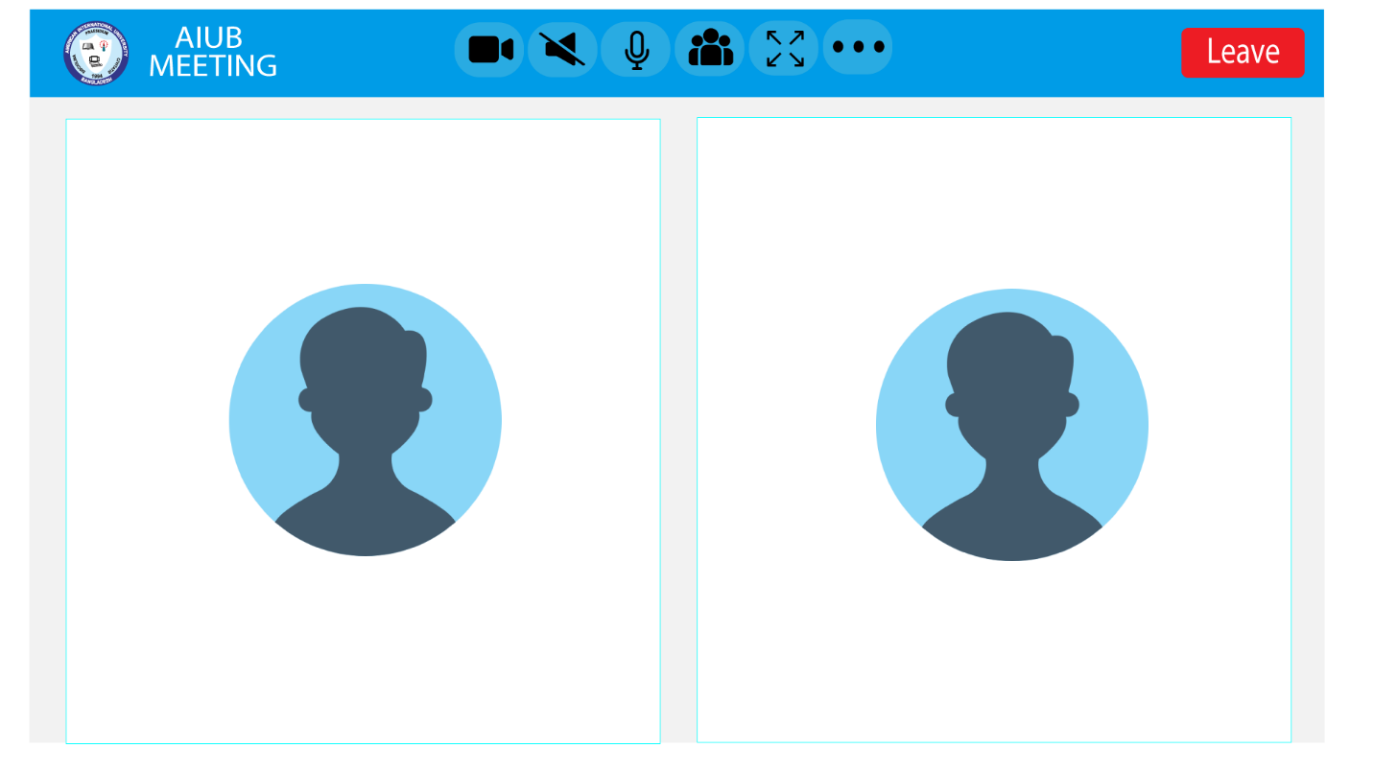

## Project Requirements

Project Estimation:

The Constructive Cost Model (COCOMO) is an algorithmic software cost estimation model**.** The software project type that we will be using is organic**.** It is a software project that must be developed within a strongly coupled to hardware environment**.**

· Effort = PM (person-months needed for project (labor working hours))

=Coefficient<Effort Factor>*(SLOC/1000)^P

=2.4* (10000/1000)^1.05 [here SLOC = 10000, organic co- efficicient

effort factor is 2.4 and P(project complexity which is 1.05)]

= 26.928 labor working hours

· Development Time, DM= 2.50*(PM)^T

· =2.50*(26.928)^0.38 [here T for organic is 0.38] =8.73 months

· Required Number of People, ST (average staffing necessary)

= PM/DM

=26.928/8.73

=3.08

Project Schudule:

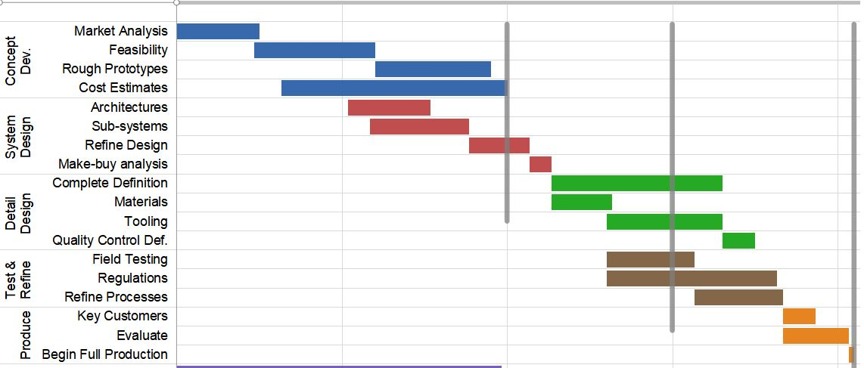

Time Schudule:

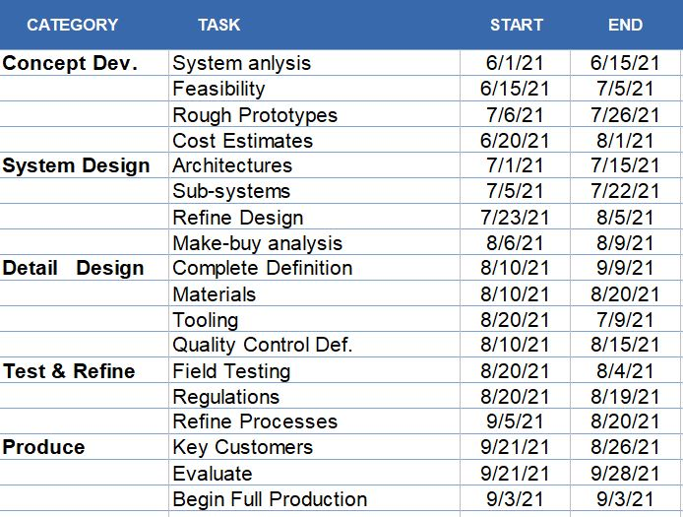

# FEATURES NOT TO BE TESTED

3 of 12 features will not be tested:

1. **Importing Profile Pic from Vues in meeting:** This is integrated with AIUB system so each user has an unique id, so display picture importing test is not necessary to identify the user.
2. **Meeting Session Log:** Meeting Session log is not necessary to be updated after meetings. A lot meetings happens daily simultaneously
3. **Real Time Emoticon send:** This is not a high-prioritized feature. We will not test this feature as of now. This will not cause problem in the functionally rather it just a fun feature

# TESTING APPROACH

## Testing Levels

The testing for the AIUB MEETING will applied Unit, System/Integration (combined) and Acceptance testing levels. We will be testing at least one user from each of the four main user roles: Student, Teacher, officer and administrator. This way, we will be able to test all of the user interface screens of the application, and we can gather feedback from each type of user.

## Unit Testing :

We applied unit testing in our AIUB MEETING. This testing will be completed by the development team. We validate each unit of the software code performs as expected. When it’s done during the development (coding phase) of an application by the developers. Proof of unit testing (test case list, sample output, data printouts, defect information) must be provided by the programmer to the team leader before unit testing will be accepted and passed on to the test person.

## System Testing :

We also applied unit testing in our AIUB MEETING. System Testing will be performed by a testing team that is independent of the development team that helps to test the quality of the system impartial. We tests the design and behavior of the system and also the expectations of the customer. It is performed to test the system beyond the bounds mentioned in the Software Requirements Specifications.

## ACCEPTANCE Testing :

Acceptance testing will be performed by the development team and project sponsors the actual end users with the assistance of the test manager. It isthe most important phase of testing as this decides whether the client approves the application/software or not. It may involve functionality, usability, performance, and U.I of the application. It is the final stages of the software’s testing cycle and often occurs before a client or customer accepts the new application.

## Test Tools

IBM Rational Functional Tester 9.2

The test tool we will be using is IBM Rational Functional Tester 9.2 . It’s an automated functional testing and regression testing tool. Rational Functional Tester is an object-oriented automated functional testing tool that tests HTML, including HTML 5, Java, Windows, .NET, Visual Basic, SAP, Silverlight, Eclipse, Siebel, Flex, Ajax, Dojo, GEF and PowerBuilder applications.

* While testing our web application our first step is to select the ‘Test Workbench Project’ from this path.Then we need to create a Test Workbench project’ screen where we can use ‘Default location’ for the project.After that we will create ‘Default folders’ for each of the ‘Asset Type’ in the project and then click ‘Finish’. A different screen of ‘Recording Session’ will be opened. There are multiple options to decide which kind of test we want to perform. Currently, we will use the ‘HTTP Test’ because here we are going to test our own web application.

AutoIT with Selenium Webdriver

Another test tool we are going to use is AutoIT with Selenium Webdriver. AutoIt is a freeware scripting language designed for automating windows GUI and general scripting. It uses a combination of mouse movement, keystrokes and window control manipulation to automate a task which is not possible by selenium webdriver.

* First we will use "Contact Us" page of our web application to upload complain( Doc file). After clicking on 'Choose File' button from the "Contact Us" page, we need to call AutoIT script. The control immediately transferred to autoit after clicking 'Choose File' by the below statement which takes care of uploading part.

*Runtime.getRuntime().exec("E:\\AutoIT\\FileUpload.exe");*

Finally, when we run selenium script-it will fill the form-> upload resume-> Submit form.

## Meetings

AIUB Classroom will allow faculties to create and schedule meetings with students for testing, individually or as a group. When a student joins a testing session, The student will follow their instructions to join the meeting. They will enter into the AIUB Classroom where Faculties will need to approve them. Once they are approved in the meeting, faculties can begin recording the session. If faculties would like, click anywhere in AIUB Classroom meeting screen. A series of options will appear. Ask the student to present their ID to faculties by holding it up to the camera and verify their identity. If faculties require, ask the student to share screen with them. They can click anywhere on their screen to view meeting options. Click on the share screen icon. Ask the student if they have any questions. Remind them of the hand raising option as well. When proctoring a test for faculties entire AIUB Classroom, they may view all of their students at once.

# TEST CASES/TEST ITEMS

|  |  |  |  |  |  |
| --- | --- | --- | --- | --- | --- |
| Project Name: AIUB MEETING | | | Test Designed by: Ehsanul Mostofa | | |
| Test Case ID: AM_1 | | | Test Designed date:8/8/2021 | | |
| Test Priority (Low, Medium, High): Medium | | | Test Executed by: Ehsanul Mostofa | | |
| Module Name: Notification Button | | | Test Execution date:12/8/2021 | | |
| Test Title: Test Notification Button | | |  | | |
| Description: Test Notification Button of ‘AIUB MEETING’ Application | | |  | | |
| Precondition (If any): N/A | | | | | |
| Test Steps | Test Data | Expected Results | | Actual Results | Status (Pass/Fail) |
| 1. Go to ‘AIUB MEETING’ App 2. Click Notification Button | Click : ‘Notifaction’ Button | Students should use the ‘Notification’ Button for viewing the latest Notice | | As expected, | Pass |
| Post Condition: Students will be able to ‘View’ Notification. | | | | | |

|  |  |  |  |  |  |
| --- | --- | --- | --- | --- | --- |
| Project Name: AIUB MEETING | | | Test Designed by:Ehsanul Mostofa | | |
| Test Case ID: AM_2 | | | Test Designed date:8/8/2021 | | |
| Test Priority (Low, Medium, High): Medium | | | Test Executed by:Ehsanul Mostofa | | |
| Module Name: Quiz Button | | | Test Execution date:12/8/2021 | | |
| Test Title : Test Quiz Button | | |  | | |
| Description: Check Quiz Button of ‘AIUB MEETING’ Application | | |  | | |
| Precondition (If any): N/A | | | | | |
| Test Steps | Test Data | Expected Results | | Actual Results | Status (Pass/Fail) |
| 1. Go to the ‘AIUB MEETING’ 2. Click ‘Quiz’ Button 3. Click ‘Upload’ Button 4. Click Done | Click : ‘Quiz’ Button  Upload : ‘Document’ button  Click : ‘Done’ | Teachers should upload any document for the purpose of taking quiz on any specific time. | | As expected | Pass |
| Post Condition: Students should be able to see whats the quiz file after the teachers have uploaded it.  They also have to submit it through ‘Submit’ button. | | | | | |

# 

|  |  |  |  |  |  |
| --- | --- | --- | --- | --- | --- |
| Project Name: AIUB MEETING | | | Test Designed by: S.M. HASIB | | |
| Test Case ID: AM_3 | | | Test Designed date:8/8/2021 | | |
| Test Priority (Low, Medium, High): High | | | Test Executed by: S.M. HASIB | | |
| Module Name: Report Problem | | | Test Execution date:12/8/2021 | | |
| Test Title : Test Report a Problem Option | | |  | | |
| Description: Check Report Button of ‘AIUB MEETING’ Application | | |  | | |
| Precondition (If any): There must be a technical error for this issue | | | | | |
| Test Steps | Test Data | Expected Results | | Actual Results | Status (Pass/Fail) |
| 1. Go to the ‘AIUB MEETING’ 2. Click ‘Report’ Button 3. Write the report 4. Click ‘Submit’ | Click : ‘Report’ Button  Write: ‘Text’in text area  Click : ‘Submit’ | Teachers Or Students should report any problem while they are using this application. | | As expected | Pass |
| Post Condition: The complaints should be stored in Universities Database and the authorites should view them. | | | | | |

|  |  |  |  |  |  |
| --- | --- | --- | --- | --- | --- |
| Project Name: AIUB MEETING | | | Test Designed by: S.M. HASIB | | |
| Test Case ID: AM_4 | | | Test Designed date:8/8/2021 | | |
| Test Priority (Low, Medium, High): Medium | | | Test Executed by: S.M. HASIB | | |
| Module Name: Assignment Button | | | Test Execution date:12/8/2021 | | |
| Test Title : Test Assignment Button | | |  | | |
| Description: Check Assignment Button of ‘AIUB MEETING’ Application | | |  | | |
| Precondition (If any): | | | | | |
| Test Steps | Test Data | Expected Results | | Actual Results | Status (Pass/Fail) |
| 1. Go to the ‘AIUB MEETING’ 2. Click ‘Assignment’ Button 3. Click ‘Upload’ Button 4. Click Done | Click : ‘Assignment’ Button  Upload : ‘Document’ button  Click : ‘Done’ | Teachers should upload Assignment through Assignment Button | | As expected | Pass |
| Post Condition: Students should be able to see whats the assignment file after the teachers have uploaded it. | | | | | |

|  |  |  |  |  |  |
| --- | --- | --- | --- | --- | --- |
| Project Name: | | | Test Designed by: AIUB Software | | |
| Test Case ID: FR_2 | | | Test Designed date: 8/08/2021 | | |
| Test Priority (Low, Medium, High): Medium | | | Test Executed by: 12/08/2021 | | |
| Module Name: Check Class Recording | | | Test Execution date: 12/08/2021 | | |
| Test Title: Check recording session and saved record file | | |  | | |
| Description: Test Recording process | | |  | | |
| Precondition (If any): User must have valid username and password | | | | | |
| Test Steps | Test Data | Expected Results | | Actual Results | Status (Pass/Fail) |
| 1. Go to the website 2. Enter meeting 3. Start recording 4. Save | StudentID:  18-36304-1 | User should record session and save file | | As expected, | Pass |

|  |  |  |  |  |  |
| --- | --- | --- | --- | --- | --- |
| Project Name: : AIUB MEETING | | | Test Designed by: AIUB Software | | |
| Test Case ID: AM_5 | | | Test Designed date: 8/08/2021 | | |
| Test Priority (Low, Medium, High): Medium | | | Test Executed by: 12/08/2021 | | |
| Module Name: Check Class Recording | | | Test Execution date: 12/08/2021 | | |
| Test Title: Check recording session and saved record file | | |  | | |
| Description: Test Recording process | | |  | | |
| Precondition (If any): User must have valid username and password | | | | | |
| Test Steps | Test Data | Expected Results | | Actual Results | Status (Pass/Fail) |
| 1. Go to the website 2. Enter meeting 3. Start recording 4. Save | StudentID:  18-36304-1 | User should record session and save file | | As expected, | Pass |
|  | | | | | |

|  |  |  |  |  |  |
| --- | --- | --- | --- | --- | --- |
| Project Name: AIUB MEETING | | | Test Designed by: AIUB Software | | |
| Test Case ID: AM_6 | | | Test Designed date: 8/08/2021 | | |
| Test Priority (Low, Medium, High): High | | | Test Executed by: Rajan Das Gupta | | |
| Module Name: Attendence | | | Test Execution date: 12/08/2021 | | |
| Test Title: Check attendence | | |  | | |
| Description: Test attendence system | | |  | | |
| Precondition (If any): User must have valid student ID | | | | | |
| Test Steps | Test Data | Expected Results | | Actual Results | Status (Pass/Fail) |
| 1. Go to the website 2. Ebter the class 3. Click attend 4. Confirm | StudentID:  18-36304-1 | User should enter studentiD and confirm | | As expected, | Pass |
|  | | | | | |

|  |  |  |  |  |  |
| --- | --- | --- | --- | --- | --- |
| Project Name: AIUB MEETING | | | Test Designed by: AIUB Software | | |
| Test Case ID: AM_7 | | | Test Designed date: 8/08/2021 | | |
| Test Priority (Low, Medium, High): High | | | Test Executed by: Rajan Das Gupta | | |
| Module Name: Check mute & unmute | | | Test Execution date: 12/08/2021 | | |
| Test Title: Check microphone control for mute/unmute | | |  | | |
| Description: Test mute and unmute function | | |  | | |
| Precondition (If any): User must have valid username and password | | | | | |
| Test Steps | Test Data | Expected Results | | Actual Results | Status (Pass/Fail) |
| 1. Go to the website 2. Enter meeting 3. Mute coversation 4. Unmute conversation | StudentID:  18-36304-1 | User can mute and unmute in the meeting room. | | As expected, | Pass |
|  | | | | | |

|  |  |  |  |  |  |
| --- | --- | --- | --- | --- | --- |
| Project Name: AIUB MEETING | | | Test Designed by: AIUB Software | | |
| Test Case ID: AM_8 | | | Test Designed date: 8/08/2021 | | |
| Test Priority (Low, Medium, High): Medium | | | Test Executed by: 12/08/2021 | | |
| Module Name: Check screen share | | | Test Execution date: 12/08/2021 | | |
| Test Title: Check screen sharing & control function | | |  | | |
| Description: Test screen share | | |  | | |
| Precondition (If any): User must have valid username and password | | | | | |
| Test Steps | Test Data | Expected Results | | Actual Results | Status (Pass/Fail) |
| 1. Go to the website 2. Enter metting 3. Start screen share 4. Stop screen share |  | User can start share screen and stop screen share | | As expected, | Pass |
|  | | | | | |

# ITEM PASS/FAIL CRITERIA

**Unit Testing** : Unit testing Pass/Fail Criteria will be evaluated by few steps and they are given below

**Unit Testing Team :** Testing team will be a group of -

* Unit Test Manager
* Test Analyst
* Project Sponsor
* Developer

**Testing Procedure and Results :** The team will be doing the following tasks-

* There will be error free codes and in time compilation
* The test will pass only if there is 100% passing rate.
* If any error found or passing rate remains below 100% it will be resolved in time.
* The limit of minor defects is <=25
* All the possible tests will be documented

**Testing Details :**

The pass/fail criteria for unit tests is very straightforward and will be determined by Junit testing framework. After the execution of our unit test suite, JUnit will mark each individual unit test indicating whether it passed or failed according to our assert statements. The entirety of our unit testing will be considered complete once all test cases pass successfully, and we have achieved at least 70% code coverage.

**Acceptance Testing :** Acceptance testing Pass/Fail Criteria will be evaluated by few steps and they are given below

**Accpetance Testing Team :** Testing team will be a group of -

* Acceptance Test Manager
* Test Analyst
* Project Sponsor
* Developers

**Testing Procedure and Results :** The team will be doing the following tasks-

* Initially all the test results will be marked as ‘Fail’.
* If the Project Sponsor reviews and implements the test the test result will be marked as ‘Pass’.
* If any error found or passing rate remains below 100% it will be resolved in time.
* Development team will also view this process
* All the possible tests will be documented

**Testing Details :**

For acceptance testing, each of our requirements from our Requirements Document will initially be marked as “Fail”. Once the project sponsors have reviewed the application for a particular requirement, if that requirement has been successfully implemented, then that requirement will be marked as “Pass”. This process will also be followed by the development team for earlier testing; however, features are not officially accepted until noted by the sponsors.

# TEST DELIVERABLES

* Test specification document: The summary of the scenarios that are going to be tested
* Test Plan: The blueprint carries testing process, sequence.
* Test Strategy: The high-level document defines the testing approach defined by Test Lead
* Test Scenario: To ensure every process flow is tested thoroughly.
* Test Designs: Formally defined way to ensure design of test.
* Test Cases: Enlists various combination of input and output to decide further rectification
* Test Logs: Complete list of series of test execution activities and running the tests.
* Bug report: Defect report of a component
* Test Summary Report: Summary of testing. Overall opinions, percentages of test pass/ Fail
* Test data: The data or input provided to the application with intent of fetching results.
* Test Status report: Track the progress of the application.
* Test Scripts: To Define steps and instructions for the test team that will ensure validation of functionality

# STAFFING AND TRAINING NEEDS

Training Needs Analysis is the process in which the company identifies training and development needs of its employees so that they can do their job effectively. It involves a complete analysis of training needs required at various levels of the organization.

A dedicated system support has been built including strategic guidance, business analysis, training staff, and help desk support from IT. This system support also includes members outside of IT, typically key stakeholders from other departments to inform strategy and road map. With this robust support in place, it is critical to keep the focus on advancing solution offerings as new technology is released to continue driving innovation forwards. The AIUB Classroom support team needs to implement internal education opportunities for the entire staff to ensure consistency in support from all levels.

Identify the correct timing when this training can be put into action immediately after to solidify understanding of the platforms and have training sessions added to their formal onboarding agenda. Too often incentives lag implementations in large organizations. AIUB Classroom support team provides visibility into the strategic plan to the platform and frequently

The AIUB Classroom support team begins to gather feedback and positive outcomes. These outcomes are then shared with the company to share results from past projects, build confidence in how the platform helps the organization, and as use cases to inspire future solutions in departments that may not be utilizing AIUB Classroom to its full potential.

AIUB Classroom can change the way teams collaborate by supporting multiple people working on one document within the Teams desktop application. Comments can be added to the Word document with mentions that automatically add tasks to the team Planner. What formerly may have been a AIUB Classroom Teams training specific to functionality within the system is now a training about working better together, with supporting technology and aligning with company culture.

providing solutions to existing problems will generate higher interest across the organization and justification for employees’ time spent learning how to use them. Having a clear process for feedback and transparency in the decision-making process will build trust with the organization, supporting the time and effort they are spending to understand the new systems. Developing these deep, trusted relationships with the changes the focus of the conversations from specific technical requests to open dialogue around challenges or opportunities for innovation.

# RESPONSIBILITIES

|  |  |  |
| --- | --- | --- |
| Name | Role | Responsibilities |
| S. M. Hasib | Project Manager | 1. Supervise the test plan 2. weekly update test strategy based on new test requirements and cases. 3. Identify test problems from datasheet to obtain solution. 4. To check if the team has all the necessary resources to execute the testing activities. 5. To check if testing is going hand in hand with the software development in all phases 6. Required Interactions with customers. 7. All responsibilities of test planning. |
| Ehsanul Mostofa | Test Lead | 1. Develop test strategy and test plans for projects. 2. The use of resources in an effective way and managing the resources for software testing. 3. Discuss the test report with project manager 4. Defining the scope of testing within the context of every release and every software testing level or cycle. 5. Updating project manager regularly about the progress of testing activities. |
| Rajan Das Gupta | Senior Test Engineer | 1. Meeting with the product design team to determine product testing parameters. 2. Troubleshooting any errors and streamlining the testing procedures. 3. Writing test plans and creating test cases for the product. 4. Direct contact lead for the resources |
| Afsana Akter Bristy | Associate Test Engineer | 1. Designing testing scenarios for testing. 2. Execute the testing. 3. Create test data and status reports for team lead. |
| Pritha Saha | Associate Test Engineer | 1. To read all the documents and understand what needs to be tested. 2. Based on the information procured in the above step decide how it is to be tested. 3. Carry out regression testing every time when changes are made to the code to fix defects. |

# TESTING SCHEDULE

Time has been allocated within the project plan for the following testing activities. The specific dates and times for each activity are defined in the project plan timeline. The persons required for each process are detailed in the project timeline and plan as well. Coordination of the personnel required for each task, test team, development team, management and customer will be handled by the project manager in conjunction with the development and test team leaders.

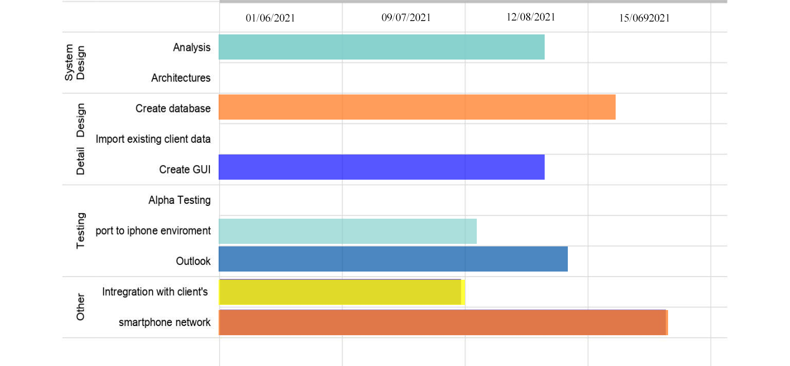

# PLANNING RISKS AND CONTINGENCIES

Risk analysis and management are intended to help a software team understand and manage uncertainty during the development process. Risk management means risk containment and mitigation. First, we’ve got to identify and plan. Then be ready to act when a risk arises, drawing upon the experience and knowledge of the entire team to minimize the impact to the project.

**Risk management includes:**

1. Identify risks and their triggers
2. Classify and prioritize all risks
3. Craft a plan that links each risk to a mitigation
4. Monitor for risk triggers during the project
5. Implement the mitigating action if any risk materializes

**There square measure 3 main classes of risks that may have an effect on a computer code project**:

**Project Risks:**

Project risks concern varies sorts of monetary fund, schedule, personnel, resource, and customer-related issues. a vital project risk is schedule slippage. Since computer code is intangible, it’s terribly tough to observe and management a computer code project. it’s terribly tough to manage one thing that can not be seen. For any producing project, like producing cars, the project manager will see the merchandise taking form.

**Technical Risks:**

Technical risks concern potential style, implementation, interfacing, testing, and maintenance issues. Technical risks conjointly embody ambiguous specifications, incomplete specification, dynamic specification, technical uncertainty, and technical degeneration. Most technical risks occur thanks to the event team’s lean information concerning the project.

**Business Risks:**

This type of risk embodies the risks of building a superb product that nobody needs, losing monetary fund or personal commitments, etc.

**For most software development projects, we can define five main risk impact areas:**

1. New, unproven technologies
2. User and functional requirements
3. Application and system architecture
4. Performance
5. Organizational

Most software engineering projects are inherently risky because of the variety potential problems that might arise. Experience from other software engineering projects can help managers classify risk. The importance here is not the elegance or range of classification, but rather to precisely identify and describe all of the real threats to project success. A simple but effective classification scheme is to arrange risks according to the areas of impact. Use of checklists – usually based on the experience of past projects. Some risk are generic risk, they are relevant to all software projects. A standard checklist can be used to identify the risks changing technology. Brainstorming – getting knowledgeable stakeholders together to pool concerns Causal mapping – identifying possible chains of cause and effect. For example, illness of a team member is a risk that might put the project completion date at risk and result in the late delivery of the product.

**Risks can be deal with by:**

Risk prevention – a project can, for example, be protected from the risk of overrunning the schedule by increasing duration estimates or reducing functionality. Risk reduction – some risk, while they cannot be prevented, can have their likelihoods reduced by prior planning. The risk of late changes to a requirements specification can, for example, be reduced by prototyping but will not eliminate the risk of late changes. Risk transfer – the impact of some risk can betransferred away from the project, by, for example, contracting out or taking out insurance.

# APROVALS

|  |  |
| --- | --- |
| **Possition** | **Assigned** |
| Project Manager – Afrida Rahman | All test cases, System test |
| Development Management - Rajan Das Gupta | Integration test, regression test |
| Design Manager - Jui Saha Pritha | UI design and functional animation test cases |
| Test team Lead - Ehsanul Mostofa | Acceptance and system testing approval, iteration test. |
| Test Engineer – Afrida Rahman | Unit test, Functionality test |
| Reassigned Sales - S.M Hasib | Data flow test, |
| QA Manager - Jui Saha Pritha | New test cases, and review test strategy |
| Client – MR. Robert | System testing, integration testing, Data flow.. |